**Internship Documentation :**

**Company Name : Akash Technolab**

**Internship technology : PHP**

**Submitted By : Ronakbhai Bharatbhai Bhalala**

**Date : 01/06/21**

**Task 1 :**

**Practice :**

**Program 1 : Database creation in phpMyAdmin and create connection and perform insertion operation.**

**Database creation :**

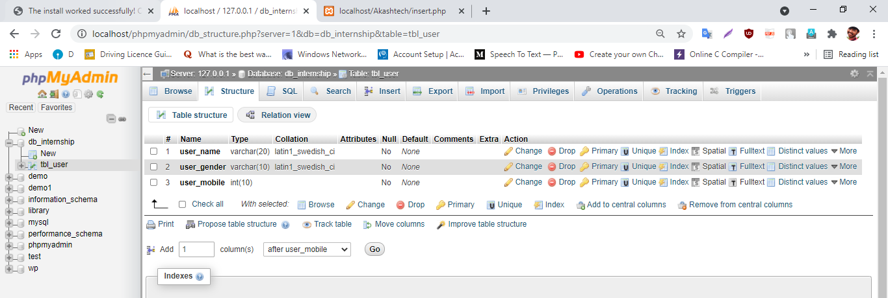

**Code for insertion of record.**

<?php

$host = "localhost";

$username = "root";

$passwd = "";

$dbname = "db_internship";

//connection function

$connection = mysqli_connect($host,$username,$passwd,$dbname);

$q = mysqli_query($connection,

"insert into tbl_user(user_name,user_gender,user_mobile) values ('ronak','male','123')")

or die("Error".mysqli_error($connection));

if($q)

{

echo "<script> alert('Record Added successfully !!');</script>";

echo $q;

}

?>

**Output:**

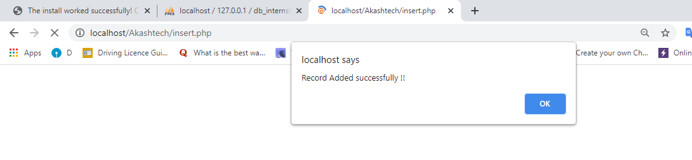

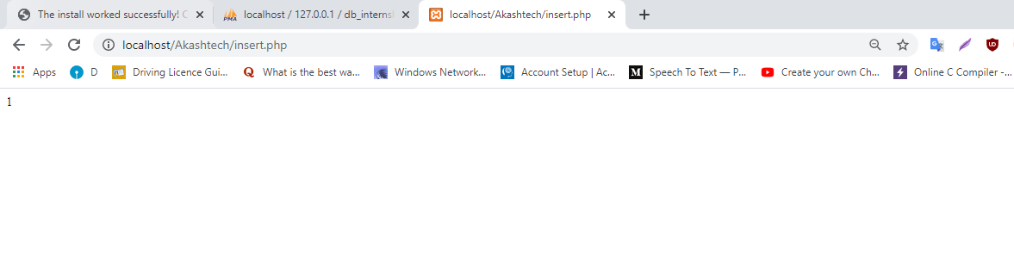

**Task 2 : Data base, table creation and insertion operation using form.**

**Database name : db_internship**

**Table name: tbl_student**

**Column :**

**St_id**

**St_name**

**St_gender**

**St_dob**

**St_email**

**St_mobile**

**St_address**

**St_password**

**St_area**

**St_pincode**

**St_bloodgroup**

**Code:-**

**1. insert form without Theme.**

**Code:**

<!doctype html>

<html>

<head>

</head>

<body>

<h1 align="center"><b>Task : 6</b></h4>

<h1 align="center"><b>Insertion operation with theme</b></h4>

<div>

<form action="niraj1.php" method="post" align="center">

<label for="fnamide">Id :</label>

<input type="text" id="id" name="id"><br><br>

<label for="name" style="margin_top:10px;";>Name:</label>

<input type="text" id="name" name="name"><br><br>

<label>Gender:</label>

<input type="radio" id="male" name="gender" value="male">

<label for="male">Male</label>

<input type="radio" id="female" name="gender" value="female">

<label for="female">Female</label>

<input type="radio" id="other" name="gender" value="other">

<label for="other">Other</label><br><br>

<label for="date">DOB:</label>

<input type="date" id="date" name="b_date"><br><br>

<label for="email">Email:</label>

<input type="email" id="email" name="email"><br><br>

<label for="number">Mobile Number:</label>

<input type="text" id="number" name="number"><br><br>

<label for="pass">Password:</label>

<input type="password" id="pass" name="pass"><br><br>

<label for="area">Area:</label>

<input type="text" id="area" name="area"><br><br>

<label>Address:</label><br>

<textarea name="address" rows="10" cols="30">

</textarea><br><br>

<label for="pincode">Pincode:</label>

<input type="text" id="pincode" name="pincode"><br><br>

<label for="blodgroup">Blodgroup:</label>

<select id="blodgroup" name="blodgroup">

<option value="">Select blodgroup</option>

<option value="A+">A+</option>

<option value="B+">B+</option>

<option value="O+">O+</option>

<option value="O-">O-</option>

</select><br><br>

<input type="submit" value="Submit" name="submit">

</form>

</div>

</body>

</html>

**Output:**

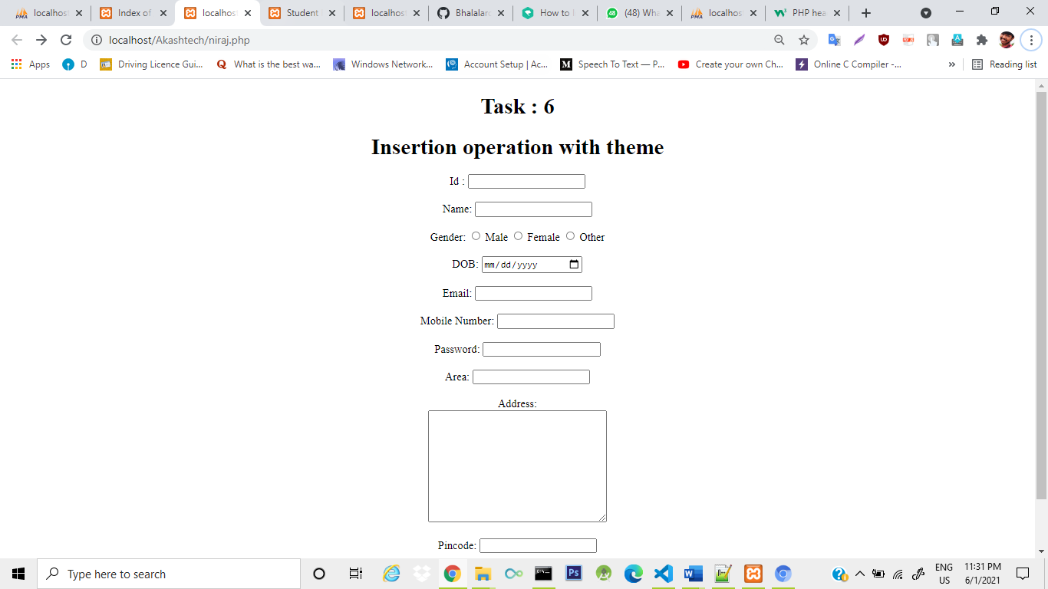

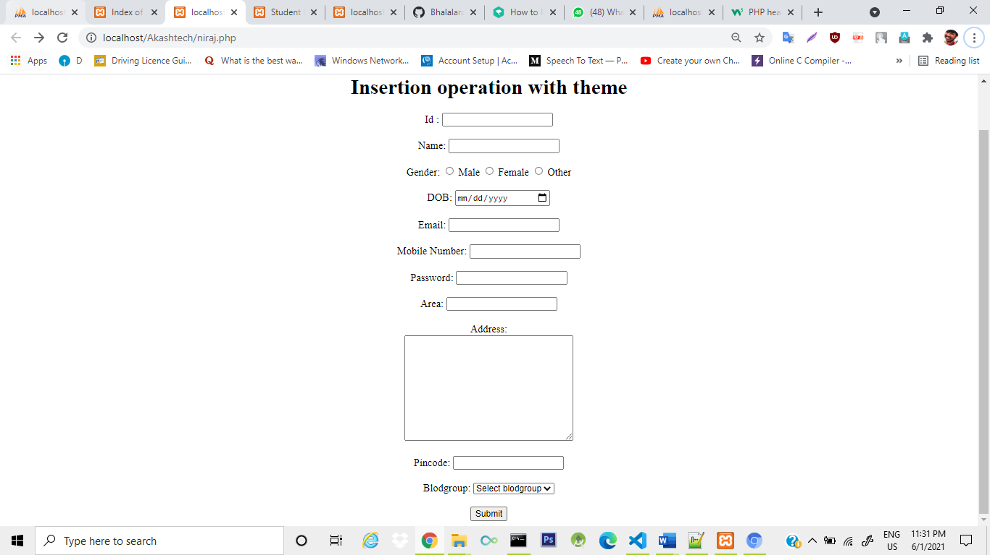

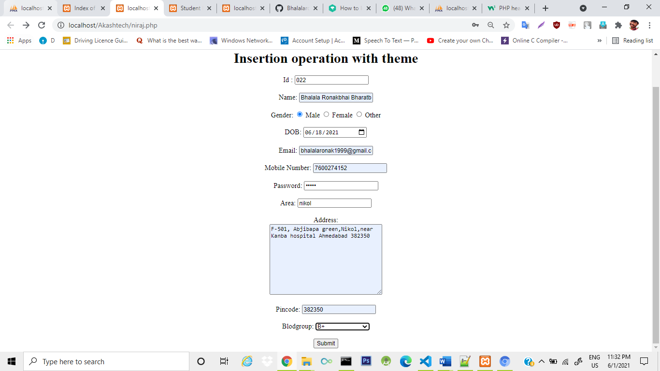

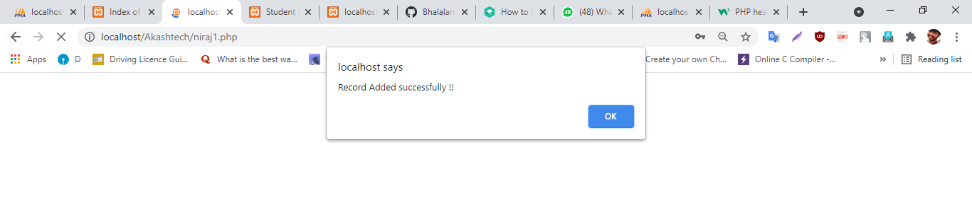

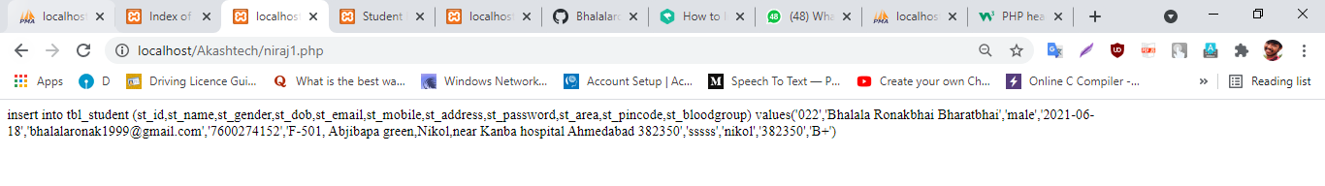

**2. insert form with Theme.**

**Code :**

<!DOCTYPE html>

<html lang="en-US">

<head>

<meta charset="UTF-8">

<!-- Favicons -->

<link href="images/ronak1010.jpg" rel="icon">

<meta http-equiv="X-UA-Compatible" content="IE=edge">

<meta name="viewport" content="width=device-width, initial-scale=1">

<title>Ronak Bhalala</title>

<meta name="description" content="Ronak bhalala" content="ronakbhalala" content="rudrabhalala" content="rudra patel" content="rudrapatel"/>

<link href="https://fonts.googleapis.com/css?family=Montserrat:400,700,200" rel="stylesheet">

<link href="https://maxcdn.bootstrapcdn.com/font-awesome/latest/css/font-awesome.min.css" rel="stylesheet">

<link href="css/aos.css" rel="stylesheet">

<link href="css/bootstrap.min.css" rel="stylesheet">

<link href="styles/main.css" rel="stylesheet">

</head>

<body id="top">

<bgsound src = "badal.mp3" />

<header>

<div class="profile-page sidebar-collapse">

<nav class="navbar navbar-expand-lg fixed-top navbar-transparent bg-primary" color-on-scroll="400">

<div class="container">

<div class="navbar-translate"><a class="navbar-brand" href="#" rel="tooltip">Ronak Bhalala</a>

<button class="navbar-toggler navbar-toggler" type="button" data-toggle="collapse" data-target="#navigation" aria-controls="navigation" aria-expanded="false" aria-label="Toggle navigation"><span class="navbar-toggler-bar bar1"></span><span class="navbar-toggler-bar bar2"></span><span class="navbar-toggler-bar bar3"></span></button>

</div>

<div class="collapse navbar-collapse justify-content-end" id="navigation">

<ul class="navbar-nav">

<li class="nav-item"><a class="nav-link smooth-scroll" href="#about">About</a></li>

<li class="nav-item"><a class="nav-link smooth-scroll" href="#skill">Skills</a></li>

<li class="nav-item"><a class="nav-link smooth-scroll" href="#portfolio">Portfolio</a></li>

<!--li class="nav-item"><a class="nav-link smooth-scroll" href="#experience">Experience</a></li-->

<li class="nav-item"><a class="nav-link smooth-scroll" href="#contact">Contact</a></li>

</ul>

</div>

</div>

</nav>

</div>

</header>

<div class="page-content">

<div>

<div class="profile-page">

<div class="wrapper">

<div class="page-header page-header-small" filter-color="green">

<div class="page-header-image" data-parallax="true" style="background-image: url('images/cover.JPG');"></div> <!-- cc-bg-1 -->

<div class="container">

<div class="content-center">

<div class="cc-profile-image"><a href="#"><img src="images/ronak1010.jpg" alt="Image"/></a></div>

<div class="h2 title">Ronak Bhalala</div>

<p class="category text-white">Computer engineer,&nbsp;Photographer,&nbsp;Photoshop editor</p><a class="btn btn-primary smooth-scroll mr-2" href="#contact" data-aos="zoom-in" data-aos-anchor="data-aos-anchor">Hire Me</a><a class="btn btn-primary" href="images/Ronakbhalala.pdf" download data-aos="zoom-in" data-aos-anchor="data-aos-anchor" download>Download Resume</a>

</div>

</div>

<div class="section">

<div class="container">

<div class="button-container"><a class="btn btn-default btn-round btn-lg btn-icon" href="https://www.facebook.com/ronak.bhalala.16" rel="tooltip" title="Follow me on Facebook"><i class="fa fa-facebook"></i></a><a class="btn btn-default btn-round btn-lg btn-icon" href="#" rel="tooltip" title="Follow me on Twitter"><i class="fa fa-twitter"></i></a><a class="btn btn-default btn-round btn-lg btn-icon" href="https://www.linkedin.com/in/ronak-bhalala-922650187" rel="tooltip" title="Follow me on Linked In"><i class="fa fa-linkedin"></i></a><a class="btn btn-default btn-round btn-lg btn-icon" href="https://instagram.com/rudraraj_patel?igshid=1rcaimltzq2vz" rel="tooltip" title="Follow me on Instagram"><i class="fa fa-instagram"></i></a></div>

</div>

</div>

</div>

</div>

</div>

<div class="section" id="about">

<div class="container">

<div class="card" data-aos="fade-up" data-aos-offset="10">

<div class="row">

<div class="col-lg-6 col-md-12">

<div class="card-body">

<div class="h4 mt-0 title">About Me</div>

<p>Hello! I am Ronak Bhalala. Web Developer,Computer Engineer ,Photographer,&nbsp;Photoshop editor.</p>

<p>I have Completed my Diploma in Computer Engineering from Government Polytechnic Ahmedabad-380015. with 8.43 CGPA</p>

<p>Currently I am studies Bachlor of Engineering in Computer Engineering at Government Engineering Colleage, Modasa - 383315</p>

<p>Looking for training and internship IT/Computer field. </p>

<p>My areas of interest are : AI, Machine learning, IoT, Cloud computing, iOS, python, Big-data analysis, Angular JS And other trending technology.</p>

</div>

</div>

<div class="col-lg-6 col-md-12">

<div class="card-body">

<div class="h4 mt-0 title">Basic Information</div>

<div class="row">

<div class="col-sm-4"><strong class="text-uppercase">Age:</strong></div>

<div class="col-sm-8">20</div>

</div>

<div class="row mt-3">

<div class="col-sm-4"><strong class="text-uppercase">Email:</strong></div>

<div class="col-sm-8">bhalalaronak1999@gmail.com</div>

</div>

<div class="row mt-3">

<div class="col-sm-4"><strong class="text-uppercase">Phone:</strong></div>

<div class="col-sm-8">+91 76002 74252</div>

</div>

<div class="row mt-3">

<div class="col-sm-4"><strong class="text-uppercase">Address:</strong></div>

<div class="col-sm-8">F-501, Abji bapa greens, new nikol near anjana chowk, Ahmedabad-382350</div>

</div>

<div class="row mt-3">

<div class="col-sm-4"><strong class="text-uppercase">Language:</strong></div>

<div class="col-sm-8">English, Hindi, Gujrati</div>

</div>

<div class="row mt-3">

<div class="col-sm-4"><strong class="text-uppercase">Maritial status:</strong></div>

<div class="col-sm-8">Single</div>

</div>

<div class="row mt-3">

<div class="col-sm-4"><strong class="text-uppercase">Hobbies:</strong></div>

<div class="col-sm-8">Crafting, Flute playing, Bike riding, Drawing, Photoediting, Traveling, Book and Magazine Reading, Nature and Potrait photography</div>

</div>

<div class="row mt-3">

<div class="col-sm-4"><strong class="text-uppercase">Nick name:</strong></div>

<div class="col-sm-8">Rudraraj</div>

</div>

</div>

</div>

</div>

</div>

</div>

</div>

<div class="section" id="skill">

<div class="container">

<div class="h4 text-center mb-4 title">Professional Skills</div>

<div class="card" data-aos="fade-up" data-aos-anchor-placement="top-bottom">

<div class="card-body">

<div class="row">

<div class="col-md-6">

<div class="progress-container progress-primary"><span class="progress-badge">HTML</span>

<div class="progress">

<div class="progress-bar progress-bar-primary" data-aos="progress-full" data-aos-offset="10" data-aos-duration="2000" role="progressbar" aria-valuenow="60" aria-valuemin="0" aria-valuemax="100" style="width: 60%;"></div><span class="progress-value">60%</span>

</div>

</div>

</div>

<div class="col-md-6">

<div class="progress-container progress-primary"><span class="progress-badge">CSS</span>

<div class="progress">

<div class="progress-bar progress-bar-primary" data-aos="progress-full" data-aos-offset="10" data-aos-duration="2000" role="progressbar" aria-valuenow="60" aria-valuemin="0" aria-valuemax="100" style="width: 60%;"></div><span class="progress-value">60%</span>

</div>

</div>

</div>

</div>

<div class="row">

<div class="col-md-6">

<div class="progress-container progress-primary"><span class="progress-badge">JavaScript</span>

<div class="progress">

<div class="progress-bar progress-bar-primary" data-aos="progress-full" data-aos-offset="10" data-aos-duration="2000" role="progressbar" aria-valuenow="60" aria-valuemin="0" aria-valuemax="100" style="width: 40%;"></div><span class="progress-value">40%</span>

</div>

</div>

</div>

<div class="col-md-6">

<div class="progress-container progress-primary"><span class="progress-badge">Php</span>

<div class="progress">

<div class="progress-bar progress-bar-primary" data-aos="progress-full" data-aos-offset="10" data-aos-duration="2000" role="progressbar" aria-valuenow="60" aria-valuemin="0" aria-valuemax="100" style="width: 60%;"></div><span class="progress-value">60%</span>

</div>

</div>

</div>

</div>

<div class="row">

<div class="col-md-6">

<div class="progress-container progress-primary"><span class="progress-badge">Bootstrap</span>

<div class="progress">

<div class="progress-bar progress-bar-primary" data-aos="progress-full" data-aos-offset="10" data-aos-duration="2000" role="progressbar" aria-valuenow="60" aria-valuemin="0" aria-valuemax="100" style="width: 40%;"></div><span class="progress-value">40%</span>

</div>

</div>

</div>

<div class="col-md-6">

<div class="progress-container progress-primary"><span class="progress-badge">Photoshop</span>

<div class="progress">

<div class="progress-bar progress-bar-primary" data-aos="progress-full" data-aos-offset="10" data-aos-duration="2000" role="progressbar" aria-valuenow="60" aria-valuemin="0" aria-valuemax="100" style="width: 60%;"></div><span class="progress-value">60%</span>

</div>

</div>

</div>

<div class="col-md-6">

<div class="progress-container progress-primary"><span class="progress-badge">Ai</span>

<div class="progress">

<div class="progress-bar progress-bar-primary" data-aos="progress-full" data-aos-offset="10" data-aos-duration="2000" role="progressbar" aria-valuenow="60" aria-valuemin="0" aria-valuemax="100" style="width: 15%;"></div><span class="progress-value">15%</span>

</div>

</div>

</div>

<div class="col-md-6">

<div class="progress-container progress-primary"><span class="progress-badge">Ms-office</span>

<div class="progress">

<div class="progress-bar progress-bar-primary" data-aos="progress-full" data-aos-offset="10" data-aos-duration="2000" role="progressbar" aria-valuenow="60" aria-valuemin="0" aria-valuemax="100" style="width: 60%;"></div><span class="progress-value">60%</span>

</div>

</div>

</div>

<div class="col-md-6">

<div class="progress-container progress-primary"><span class="progress-badge">IOT</span>

<div class="progress">

<div class="progress-bar progress-bar-primary" data-aos="progress-full" data-aos-offset="10" data-aos-duration="2000" role="progressbar" aria-valuenow="60" aria-valuemin="0" aria-valuemax="100" style="width: 20%;"></div><span class="progress-value">20%</span>

</div>

</div>

</div>

<div class="col-md-6">

<div class="progress-container progress-primary"><span class="progress-badge">Python for data science and machine learning</span>

<div class="progress">

<div class="progress-bar progress-bar-primary" data-aos="progress-full" data-aos-offset="10" data-aos-duration="2000" role="progressbar" aria-valuenow="60" aria-valuemin="0" aria-valuemax="100" style="width: 31%;"></div><span class="progress-value">31%</span>

</div>

</div>

</div>

</div>

</div>

</div>

</div>

</div>

<div class="section" id="portfolio">

<div class="container">

<div class="row">

<div class="col-md-6 ml-auto mr-auto">

<div class="h4 text-center mb-4 title">Portfolio</div>

<div class="nav-align-center">

<ul class="nav nav-pills nav-pills-primary" role="tablist">

<li class="nav-item"><a class="nav-link active" data-toggle="tab" href="#web-development" role="tablist"><i class="fa fa-laptop" aria-hidden="true"></i></a></li>

<li class="nav-item"><a class="nav-link" data-toggle="tab" href="#graphic-design" role="tablist"><i class="fa fa-picture-o" aria-hidden="true"></i></a></li>

<li class="nav-item"><a class="nav-link" data-toggle="tab" href="#Photography" role="tablist"><i class="fa fa-camera" aria-hidden="true"></i></a></li>

</ul>

</div>

</div>

</div>

<div class="tab-content gallery mt-5">

<div class="tab-pane active" id="web-development">

<div class="ml-auto mr-auto">

<div class="row">

<div class="col-md-6">

<div class="cc-porfolio-image img-raised" data-aos="fade-up" data-aos-anchor-placement="top-bottom"><a href="#web-development">

<figure class="cc-effect"><img src="images/project-1.jpg" alt="Image"/>

<figcaption>

<div class="h4">Recent Project</div>

<p>Web Development</p>

</figcaption>

</figure></a></div>

<div class="cc-porfolio-image img-raised" data-aos="fade-up" data-aos-anchor-placement="top-bottom"><a href="#web-development">

<figure class="cc-effect"><img src="images/project-2.jpg" alt="Image"/>

<figcaption>

<div class="h4">Startup Project</div>

<p>Web Development</p>

</figcaption>

</figure></a></div>

</div>

<div class="col-md-6">

<div class="cc-porfolio-image img-raised" data-aos="fade-up" data-aos-anchor-placement="top-bottom"><a href="#web-development">

<figure class="cc-effect"><img src="images/project-3.jpg" alt="Image"/>

<figcaption>

<div class="h4">Food Order Project</div>

<p>Web Development</p>

</figcaption>

</figure></a></div>

<div class="cc-porfolio-image img-raised" data-aos="fade-up" data-aos-anchor-placement="top-bottom"><a href="#web-development">

<figure class="cc-effect"><img src="images/project-4.jpg" alt="Image"/>

<figcaption>

<div class="h4">Web Advertising Project</div>

<p>Web Development</p>

</figcaption>

</figure></a></div>

</div>

</div>

</div>

</div>

<div class="tab-pane" id="graphic-design" role="tabpanel">

<div class="ml-auto mr-auto">

<div class="row">

<div class="col-md-6">

<div class="cc-porfolio-image img-raised" data-aos="fade-up" data-aos-anchor-placement="top-bottom"><a href="#graphic-design">

<figure class="cc-effect"><img src="images/graphic-design-1.jpg" alt="Image"/>

<figcaption>

<div class="h4">Triangle Pattern</div>

<p>Graphic Design</p>

</figcaption>

</figure></a></div>

<div class="cc-porfolio-image img-raised" data-aos="fade-up" data-aos-anchor-placement="top-bottom"><a href="#graphic-design">

<figure class="cc-effect"><img src="images/graphic-design-2.jpg" alt="Image"/>

<figcaption>

<div class="h4">Abstract Umbrella</div>

<p>Graphic Design</p>

</figcaption>

</figure></a></div>

</div>

<div class="col-md-6">

<div class="cc-porfolio-image img-raised" data-aos="fade-up" data-aos-anchor-placement="top-bottom"><a href="#graphic-design">

<figure class="cc-effect"><img src="images/graphic-design-3.jpg" alt="Image"/>

<figcaption>

<div class="h4">Cube Surface Texture</div>

<p>Graphic Design</p>

</figcaption>

</figure></a></div>

<div class="cc-porfolio-image img-raised" data-aos="fade-up" data-aos-anchor-placement="top-bottom"><a href="#graphic-design">

<figure class="cc-effect"><img src="images/graphic-design-4.jpg" alt="Image"/>

<figcaption>

<div class="h4">Abstract Line</div>

<p>Graphic Design</p>

</figcaption>

</figure></a></div>

</div>

</div>

</div>

</div>

<div class="tab-pane" id="Photography" role="tabpanel">

<div class="ml-auto mr-auto">

<div class="row">

<div class="col-md-6">

<div class="cc-porfolio-image img-raised" data-aos="fade-up" data-aos-anchor-placement="top-bottom"><a href="#Photography">

<figure class="cc-effect"><img src="images/pf1.jpg" alt="Image"/>

<figcaption>

<div class="h4">Photoshoot</div>

<p>Photography</p>

</figcaption>

</figure></a></div>

<div class="cc-porfolio-image img-raised" data-aos="fade-up" data-aos-anchor-placement="top-bottom"><a href="#Photography">

<figure class="cc-effect"><img src="images/pf2.jpg" alt="Image"/>

<figcaption>

<div class="h4">Nature photoshoot</div>

<p>Photography</p>

</figcaption>

</figure></a></div>

</div>

<div class="col-md-6">

<div class="cc-porfolio-image img-raised" data-aos="fade-up" data-aos-anchor-placement="top-bottom"><a href="#Photography">

<figure class="cc-effect"><img src="images/pf3.jpg" alt="Image"/>

<figcaption>

<div class="h4">Nature Photoshoot</div>

<p>Photography</p>

</figcaption>

</figure></a></div>

<div class="cc-porfolio-image img-raised" data-aos="fade-up" data-aos-anchor-placement="top-bottom"><a href="#Photography">

<figure class="cc-effect"><img src="images/012.JPG" alt="Image"/>

<figcaption>

<div class="h4">Modeling Photoshoot</div>

<p>Photography</p>

</figcaption>

</figure></a></div>

</div>

</div>

</div>

</div>

</div>

</div>

</div>

<!--div class="section" id="experience">

<div class="container cc-experience">

<div class="h4 text-center mb-4 title">Work Experience</div>

<div class="card">

<div class="row">

<div class="col-md-3 bg-primary" data-aos="fade-right" data-aos-offset="50" data-aos-duration="500">

<div class="card-body cc-experience-header">

<p>January 2019 - Present</p>

<div class="h5">Dharmnandan Agency</div>

</div>

</div>

<div class="col-md-9" data-aos="fade-left" data-aos-offset="50" data-aos-duration="500">

<div class="card-body">

<div class="h5">Employee-DTDC DRS processing management</div>

<p>Currenty worked as a Employee-DTDC DRS processing management. As part-time. </p>

</div>

</div>

</div>

</div>

<div class="card">

<div class="row">

<div class="col-md-3 bg-primary" data-aos="fade-right" data-aos-offset="50" data-aos-duration="500">

<div class="card-body cc-experience-header">

<p>January 2019 - Present</p>

<div class="h5">Infinity technology</div>

</div>

</div>

<div class="col-md-9" data-aos="fade-left" data-aos-offset="50" data-aos-duration="500">

<div class="card-body">

<div class="h5">technician</div>

<p>Currenty working there as technician. worked as a technician. here i work part-time</p>

</div>

</div>

</div>

</div>

<div class="card">

<div class="row">

<div class="col-md-3 bg-primary" data-aos="fade-right" data-aos-offset="50" data-aos-duration="500">

<div class="card-body cc-experience-header">

<p>October 2018 - Present</p>

<div class="h5">Malhar modeling studio</div>

</div>

</div>

<div class="col-md-9" data-aos="fade-left" data-aos-offset="50" data-aos-duration="500">

<div class="card-body">

<div class="h5">Photoshop editor , photographer</div>

<p>Here i work part-time as a photoshop editor and photographer.</p>

</div>

</div>

</div>

</div>

<div class="card">

<div class="row">

<div class="col-md-3 bg-primary" data-aos="fade-right" data-aos-offset="50" data-aos-duration="500">

<div class="card-body cc-experience-header">

<p>October 2018 - October 2018</p>

<div class="h5">Snp inatative</div>

</div>

</div>

<div class="col-md-9" data-aos="fade-left" data-aos-offset="50" data-aos-duration="500">

<div class="card-body">

<div class="h5">Wordpress </div>

<p>I have a three month work experience at snp inatative at nikol. job profile is wordpress theme customization also an image editor. a short term job experience is there. i worked there part-time</p>

</div>

</div>

</div>

</div>

</div>

</div-->

<div class="section">

<div class="container cc-education">

<div class="h4 text-center mb-4 title">Education</div>

<div class="card">

<div class="row">

<div class="col-md-3 bg-primary" data-aos="fade-right" data-aos-offset="50" data-aos-duration="500">

<div class="card-body cc-education-header">

<p>2019 - Present</p>

<div class="h5">BE In Computer Engineering</div>

</div>

</div>

<div class="col-md-9" data-aos="fade-left" data-aos-offset="50" data-aos-duration="500">

<div class="card-body">

<div class="h5">Government Engineering College Modasa</div>

<p class="category">Gujrat technological University </p>

<p>Pursing a Degree in Computer Engineering. In third year.</p>

</div>

</div>

</div>

</div>

<div class="card">

<div class="row">

<div class="col-md-3 bg-primary" data-aos="fade-right" data-aos-offset="50" data-aos-duration="500">

<div class="card-body cc-education-header">

<p>2018 - 2019</p>

<div class="h5">ITI</div>

</div>

</div>

<div class="col-md-9" data-aos="fade-left" data-aos-offset="50" data-aos-duration="500">

<div class="card-body">

<div class="h5">ITI kubernagar</div>

<p class="category">NCVT Delhi</p>

<p> I have Compleated computer operator cum programming asistant from ITI Kubernagar.</p>

</div>

</div>

</div>

</div>

<div class="card">

<div class="row">

<div class="col-md-3 bg-primary" data-aos="fade-right" data-aos-offset="50" data-aos-duration="500">

<div class="card-body cc-education-header">

<p>2015 - 2018</p>

<div class="h5">Diploma Degree</div>

</div>

</div>

<div class="col-md-9" data-aos="fade-left" data-aos-offset="50" data-aos-duration="500">

<div class="card-body">

<div class="h5">Government Polytechnic</div>

<p class="category">Gujrat technological University </p>

<p> I have Compleated computer engineering .</p>

</div>

</div>

</div>

</div>

<div class="card">

<div class="row">

<div class="col-md-3 bg-primary" data-aos="fade-right" data-aos-offset="50" data-aos-duration="500">

<div class="card-body cc-education-header">

<p>2012 - 2015</p>

<div class="h5">High School</div>

</div>

</div>

<div class="col-md-9" data-aos="fade-left" data-aos-offset="50" data-aos-duration="500">

<div class="card-body">

<div class="h5">Shree cl saraswati kunj kathwada</div>

<p class="category">Gujrat Secondary board</p>

<p>Standard 8 to 10.</p>

</div>

</div>

</div>

</div>

<div class="card">

<div class="row">

<div class="col-md-3 bg-primary" data-aos="fade-right" data-aos-offset="50" data-aos-duration="500">

<div class="card-body cc-education-header">

<p>2004 - 2012</p>

<div class="h5">Primary School</div>

</div>

</div>

<div class="col-md-9" data-aos="fade-left" data-aos-offset="50" data-aos-duration="500">

<div class="card-body">

<div class="h5">Smt. vimlaben chinubhai</div>

<p class="category">School board</p>

<p>from standard jr. kg to 7</p>

</div>

</div>

</div>

</div>

</div>

</div>

<div class="section" id="reference">

<div class="container cc-reference">

<div class="h4 mb-4 text-center title">Declaration</div>

<div class="card" data-aos="zoom-in">

<div class="carousel slide" id="cc-Indicators" data-ride="carousel">

<!--ol class="carousel-indicators">

<li class="active" data-target="#cc-Indicators" data-slide-to="0"></li>

<li data-target="#cc-Indicators" data-slide-to="1"></li>

<li data-target="#cc-Indicators" data-slide-to="2"></li>

</ol-->

<div class="carousel-inner">

<div class="carousel-item active">

<div class="row">

<!--div class="col-lg-2 col-md-3 cc-reference-header"><img src="images/reference-image-1.jpg" alt="Image"/>

<div class="h5 pt-2">Aiyana</div>

<p class="category">CEO / WEBM</p>

</div-->

<div class="col-lg-10 col-md-9">

<p> All information are right to my knowledge.i will display certificate if you say.</p>

</div>

</div>

</div>

<!--div class="carousel-item">

<div class="row">

<div class="col-lg-2 col-md-3 cc-reference-header"><img src="images/reference-image-2.jpg" alt="Image"/>

<div class="h5 pt-2">Braiden</div>

<p class="category">CEO / Creativem</p>

</div>

<div class="col-lg-10 col-md-9">

<p> Habitasse venenatis commodo tempor eleifend arcu sociis sollicitudin ante pulvinar ad, est porta cras erat ullamcorper volutpat metus duis platea convallis, tortor primis ac quisque etiam luctus nisl nullam fames. Ligula purus suscipit tempus nascetur curabitur donec nam ullamcorper, laoreet nullam mauris dui aptent facilisis neque elementum ac, risus semper felis parturient fringilla rhoncus eleifend.</p>

</div>

</div>

</div>

<div class="carousel-item">

<div class="row">

<div class="col-lg-2 col-md-3 cc-reference-header"><img src="images/reference-image-3.jpg" alt="Image"/>

<div class="h5 pt-2">Alexander</div>

<p class="category">CEO / Webnote</p>

</div>

<div class="col-lg-10 col-md-9">

<p> Habitasse venenatis commodo tempor eleifend arcu sociis sollicitudin ante pulvinar ad, est porta cras erat ullamcorper volutpat metus duis platea convallis, tortor primis ac quisque etiam luctus nisl nullam fames. Ligula purus suscipit tempus nascetur curabitur donec nam ullamcorper, laoreet nullam mauris dui aptent facilisis neque elementum ac, risus semper felis parturient fringilla rhoncus eleifend.</p>

</div>

</div>

</div>

</div>

</div-->

</div>

</div>

</div>

<div class="section" id="contact">

<div class="cc-contact-information" style="background-image: url('images/staticmap.png');">

<div class="container">

<div class="cc-contact">

<div class="row">

<div class="col-md-9">

<div class="card mb-0" data-aos="zoom-in">

<div class="h4 text-center title">Contact Me</div>

<div class="row">

<div class="col-md-6">

<div class="card-body">

<form action="bhalalaronak1999@gmail.com" method="POST">

<!--div class="p pb-3" ><strong>Feel free to contact me </strong></div-->

<iframe class="row mb-3" class="col" class="p pb-3" src="https://docs.google.com/forms/d/e/1FAIpQLScqEwiB8Kc9HIWOVZIvexOe9bhZvn5cL6_8FOvTBy7bpQWtNw/viewform?embedded=true" width="300" height="700" frameborder="0" marginheight="0" marginwidth="0">Loading…</iframe>

<!--div class="row mb-3">

<div class="col">

<div class="input-group"><span class="input-group-addon"><i class="fa fa-user-circle"></i></span>

<input class="form-control" type="text" name="name" placeholder="Name" required="required"/>

</div>

</div>

</div>

<div class="row mb-3">

<div class="col">

<div class="input-group"><span class="input-group-addon"><i class="fa fa-file-text"></i></span>

<input class="form-control" type="text" name="Subject" placeholder="Subject" required="required"/>

</div>

</div>

</div>

<div class="row mb-3">

<div class="col">

<div class="input-group"><span class="input-group-addon"><i class="fa fa-envelope"></i></span>

<input class="form-control" type="email" name="_replyto" placeholder="E-mail" required="required"/>

</div>

</div>

</div>

<div class="row mb-3">

<div class="col">

<div class="form-group">

<textarea class="form-control" name="message" placeholder="Your Message" required="required"></textarea>

</div>

</div>

</div>

<div class="row">

<div class="col">

<button class="btn btn-primary" type="submit">Send</button>

</div>

</div-->

</form>

</div>

</div>

<div class="col-md-6">

<div class="card-body">

<p class="mb-0"><strong>Address </strong></p>

<p class="pb-2">F-501, Abji bapa greens, new nikol near anjana chowk, Ahmedabad-382350</p>

<p class="mb-0"><strong>Phone</strong></p>

<p class="pb-2">+91 7600274152</p>

<p class="mb-0"><strong>Email</strong></p>

<p>bhalalaronak1999@gmail.com</p>

</div>

</div>

</div>

</div>

</div>

</div>

</div>

</div>

</div>

</div></div>

</div>

<div>

<h4 align="center"><b>Task : 6</b></h4>

<h4 align="center"><b>Insertion operation with theme</b></h4>

<form action="niraj1.php" method="post" align="center">

<label for="fnamide">Id :</label>

<input type="text" id="id" name="id"><br><br>

<label for="name">Name:</label>

<input type="text" id="name" name="name"><br><br>

<label>Gender:</label>

<input type="radio" id="male" name="gender" value="male">

<label for="male">Male</label>

<input type="radio" id="female" name="gender" value="female">

<label for="female">Female</label>

<input type="radio" id="other" name="gender" value="other">

<label for="other">Other</label><br><br>

<label for="date">DOB:</label>

<input type="date" id="date" name="b_date"><br><br>

<label for="email">Email:</label>

<input type="email" id="email" name="email"><br><br>

<label for="number">Mobile Number:</label>

<input type="text" id="number" name="number"><br><br>

<label for="pass">Password:</label>

<input type="password" id="pass" name="pass"><br><br>

<label for="area">Area:</label>

<input type="text" id="area" name="area"><br><br>

<label>Address:</label><br>

<textarea name="address" rows="10" cols="30">

</textarea><br><br>

<label for="pincode">Pincode:</label>

<input type="text" id="pincode" name="pincode"><br><br>

<label for="blodgroup">Blodgroup:</label>

<select id="blodgroup" name="blodgroup">

<option value="">Select blodgroup</option>

<option value="A+">A+</option>

<option value="B+">B+</option>

<option value="O+">O+</option>

<option value="O-">O-</option>

</select><br><br>

<input type="submit" value="Submit" name="submit">

</form>

</div>

<footer class="footer">

<div class="container text-center"><a class="cc-facebook btn btn-link" href="#"><i class="fa fa-facebook fa-2x " aria-hidden="true"></i></a><a class="cc-twitter btn btn-link " href="#"><i class="fa fa-twitter fa-2x " aria-hidden="true"></i></a><a class="cc-google-plus btn btn-link" href="#"><i class="fa fa-linkedin fa-2x" aria-hidden="true"></i></a><a class="cc-instagram btn btn-link" href="#"><i class="fa fa-instagram fa-2x " aria-hidden="true"></i></a></div>

<div class="h4 title text-center">Ronak Bhalala</div>

<div class="text-center text-muted">

<!--p>&copy; Creative CV. All rights reserved.<br>Design - <a class="credit" href="https://templateflip.com" target="_blank">TemplateFlip</a></p-->

</div>

</footer>

<script src="js/core/jquery.3.2.1.min.js"></script>

<script src="js/core/popper.min.js"></script>

<script src="js/core/bootstrap.min.js"></script>

<script src="js/now-ui-kit.js?v=1.1.0"></script>

<script src="js/aos.js"></script>

<script src="scripts/main.js"></script>

</body>

</html>

**Output:**

